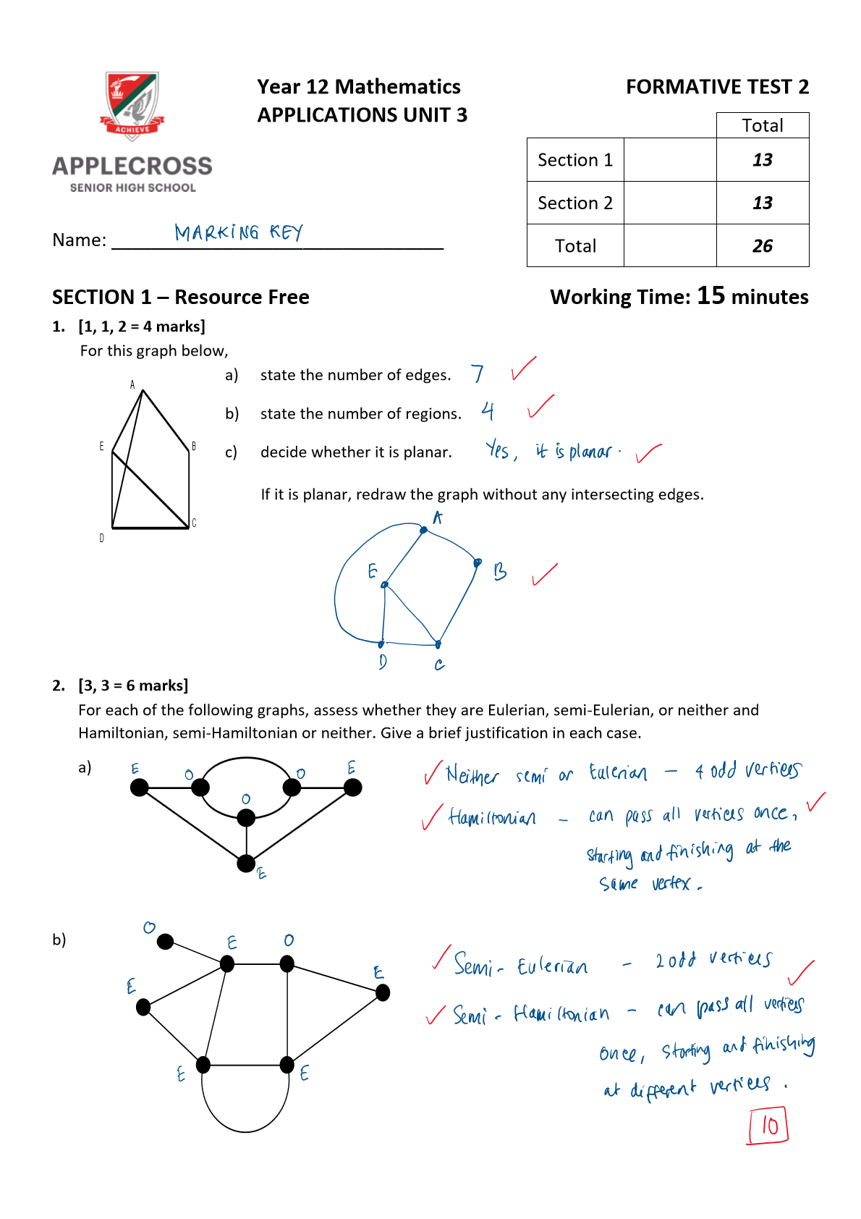

5. 2, 3 • 7 marks] 
Consider the following graph. 
D 
There are 5 routes from A to A Of length 2. These routes are: A-A* Via the top edge, A-g-A Via the 
lower edge. via top then bottom edges, via bottom then top edges and 
a) List all possible routes from A to O of 
Abp, ACT) 
b) Construct an adjacency matrix (M) for the graph above. 
6 
2 
o 
2 
C) 
D 
c) Determine how many walks of length 4 there are from C to B. Justify pur answer. 
0 
7 
END OF TEST 